Predicting Hotel Booking Cancellations
An Exploratory Data Analysis and Machine Learning Study
AI-assisted Group Assignment Report
Item | Details
Domain | Hospitality / Revenue Management (Marketing & Operations)
Dataset | hotel_bookings.csv (119,390 bookings x 32 variables)
Target variable | is_canceled (0 = Not canceled, 1 = Canceled)
Techniques | EDA, SMOTE, Logistic Regression, Decision Tree, Random Forest (tuned)
Group members | [Add names and roll numbers]
Course / Institute | [Add course name and institute]
Submission date | [Add date]

1. Problem Statement

1a. Domain of the study
Hospitality and tourism, specifically hotel revenue management, which sits at the intersection of marketing (distribution channels, customer segments, pricing) and operations (inventory and capacity planning).

1b. Broad problem of the study
Booking cancellations are one of the largest sources of revenue uncertainty for hotels. In this dataset 37.0% of all bookings (44,224 of 119,390) were cancelled. A cancelled room that is not resold leaves revenue unrealised, while the common defensive response of overbooking risks walking guests to other hotels. The broad problem is therefore:
"Can a hotel predict, at the time of booking, whether a reservation will be cancelled, and which booking characteristics drive cancellation?"
This is a supervised binary classification problem. Predicting cancellation risk lets a hotel manage overbooking, deposit and reminder policies and channel strategy on evidence rather than intuition.

2. Variables of the Study
The dataset has 32 variables. The table below lists all of them with their type. "Scale" variables are numeric measures; "Categorical" variables are labels or codes (including binary indicators and ID-like codes).
S.No | Variable name | Type of variable
1 | hotel | Categorical (nominal)
2 | is_canceled | Categorical (binary) - TARGET
3 | lead_time | Scale (days)
4 | arrival_date_year | Scale (discrete)
5 | arrival_date_month | Categorical (ordinal)
6 | arrival_date_week_number | Scale (discrete)
7 | arrival_date_day_of_month | Scale (discrete)
8 | stays_in_weekend_nights | Scale (count)
9 | stays_in_week_nights | Scale (count)
10 | adults | Scale (count)
11 | children | Scale (count)
12 | babies | Scale (count)
13 | meal | Categorical (nominal)
14 | country | Categorical (nominal, ISO code)
15 | market_segment | Categorical (nominal)
16 | distribution_channel | Categorical (nominal)
17 | is_repeated_guest | Categorical (binary)
18 | previous_cancellations | Scale (count)
19 | previous_bookings_not_canceled | Scale (count)
20 | reserved_room_type | Categorical (nominal)
21 | assigned_room_type | Categorical (nominal)
22 | booking_changes | Scale (count)
23 | deposit_type | Categorical (nominal)
24 | agent | Categorical (ID code)
25 | company | Categorical (ID code)
26 | days_in_waiting_list | Scale (days)
27 | customer_type | Categorical (nominal)
28 | adr (average daily rate) | Scale (currency)
29 | required_car_parking_spaces | Scale (count)
30 | total_of_special_requests | Scale (count)
31 | reservation_status | Categorical (nominal) - post-outcome
32 | reservation_status_date | Date - post-outcome
Table 1: Variables of the study
Important: reservation_status and reservation_status_date record what finally happened to the booking, so they would "leak" the answer and are excluded from the models. agent and company are anonymised identifiers rather than measurements, so they are also excluded from modelling (they remain in the descriptive tables for completeness).

3. Descriptive Statistics for Scale Variables
Variable | Mean | Median | Std | Min | Max | Skew
is_canceled | 0.37 | 0.0 | 0.48 | 0.0 | 1.0 | 0.54
lead_time | 104.01 | 69.0 | 106.86 | 0.0 | 737.0 | 1.35
arrival_date_year | 2016.16 | 2016.0 | 0.71 | 2015.0 | 2017.0 | -0.23
arrival_date_week_number | 27.17 | 28.0 | 13.61 | 1.0 | 53.0 | -0.01
arrival_date_day_of_month | 15.8 | 16.0 | 8.78 | 1.0 | 31.0 | -0.0
stays_in_weekend_nights | 0.93 | 1.0 | 1.0 | 0.0 | 19.0 | 1.38
stays_in_week_nights | 2.5 | 2.0 | 1.91 | 0.0 | 50.0 | 2.86
adults | 1.86 | 2.0 | 0.58 | 0.0 | 55.0 | 18.32
children | 0.1 | 0.0 | 0.4 | 0.0 | 10.0 | 4.11
babies | 0.01 | 0.0 | 0.1 | 0.0 | 10.0 | 24.65
is_repeated_guest | 0.03 | 0.0 | 0.18 | 0.0 | 1.0 | 5.33
previous_cancellations | 0.09 | 0.0 | 0.84 | 0.0 | 26.0 | 24.46
previous_bookings_not_canceled | 0.14 | 0.0 | 1.5 | 0.0 | 72.0 | 23.54
booking_changes | 0.22 | 0.0 | 0.65 | 0.0 | 21.0 | 6.0
agent | 86.69 | 14.0 | 110.77 | 1.0 | 535.0 | 1.09
company | 189.27 | 179.0 | 131.66 | 6.0 | 543.0 | 0.6
days_in_waiting_list | 2.32 | 0.0 | 17.59 | 0.0 | 391.0 | 11.94
adr | 101.83 | 94.58 | 50.54 | -6.38 | 5400.0 | 10.53
required_car_parking_spaces | 0.06 | 0.0 | 0.25 | 0.0 | 8.0 | 4.16
total_of_special_requests | 0.57 | 0.0 | 0.79 | 0.0 | 5.0 | 1.35
Table 2: Descriptive statistics of scale variables (is_canceled shown as a 0/1 indicator; its mean is the cancellation rate)

3a. Explanation of the variables
- lead_time: Mean 104 days, median 69, maximum 737. The mean well above the median and a skewness of 1.35 show a right-skewed distribution: most guests book within a few months, but a long tail books more than a year ahead. Cancelled bookings averaged 145 days of lead time against 80 for honoured ones, making it the strongest numeric correlate of cancellation (r = 0.29), since long horizons give more time for plans to change.
- adr: Mean 101.8 with median 94.6, but a maximum of 5,400 and a negative minimum (-6.38). The skew of 10.5 is driven by a single extreme record and a handful of invalid values, which are data-quality issues rather than genuine prices. Its correlation with cancellation is weak (0.05).
- stays_in_weekend_nights / stays_in_week_nights: Typical stays are about one weekend night and two week nights (means 0.93 and 2.50). Maxima of 19 and 50 nights are rare long stays. Neither is meaningfully related to cancellation (r near 0.00 and 0.03).
- adults, children, babies: The typical booking is two adults (mean 1.86, median 2) and almost no children (mean 0.10) or babies (0.01). Maxima of 55 adults and 10 babies are group bookings or likely entry errors; 4 children values are missing. Adults has 24.9% IQR outliers only because the interquartile range is zero at 2.
- previous_cancellations and previous_bookings_not_canceled: Both are heavily skewed (about 24) because about 92% of bookings have no booking history. For the minority with history, previous cancellations are a strong warning sign (r = 0.11 overall, and the top positive driver in the logistic model).
- booking_changes: Mean 0.22. About 85% of bookings are never changed, and those that were changed cancel less often (r = -0.14), suggesting amendment signals commitment.
- total_of_special_requests and required_car_parking_spaces: Means of 0.57 and 0.06. These are the two most negatively correlated variables with cancellation (r = -0.24 and -0.20): a guest who has asked for something or reserved parking has invested in the stay. In fact, none of the bookings that reserved a parking space was cancelled (0%, versus 39.5% for those without), which is why the models treat parking as a very strong signal.
- days_in_waiting_list: Mean 2.3 but 96.9% are zero and the maximum is 391 - an extremely skewed, mostly empty variable with a very weak relationship to cancellation (0.05).
- arrival_date_year, week_number, day_of_month: Time indicators covering 2015-2017. Week number (1-53) and day (1-31) are essentially symmetric and show no linear relation to cancellation; seasonality is better seen through month (Section 4).
- agent and company: Numeric codes, not quantities, so their means carry no meaning. company is 94.3% missing and agent 13.7% missing (see Section 5).

3b. Graphs and charts
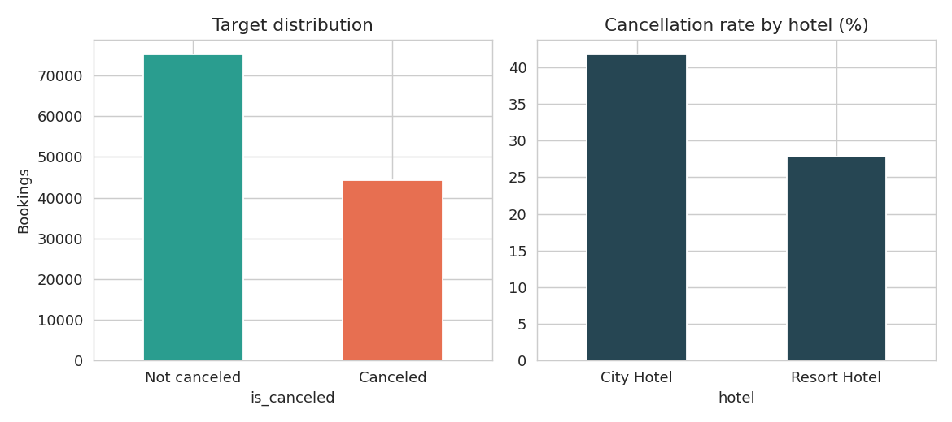
Figure 1: Target distribution and cancellation rate by hotel type
Figure 1 shows that 63.0% of bookings are honoured and 37.0% are cancelled - an imbalanced but not extreme target. City Hotel cancels far more (41.7%) than Resort Hotel (27.8%), consistent with city stays being more often for business or flexible trips.
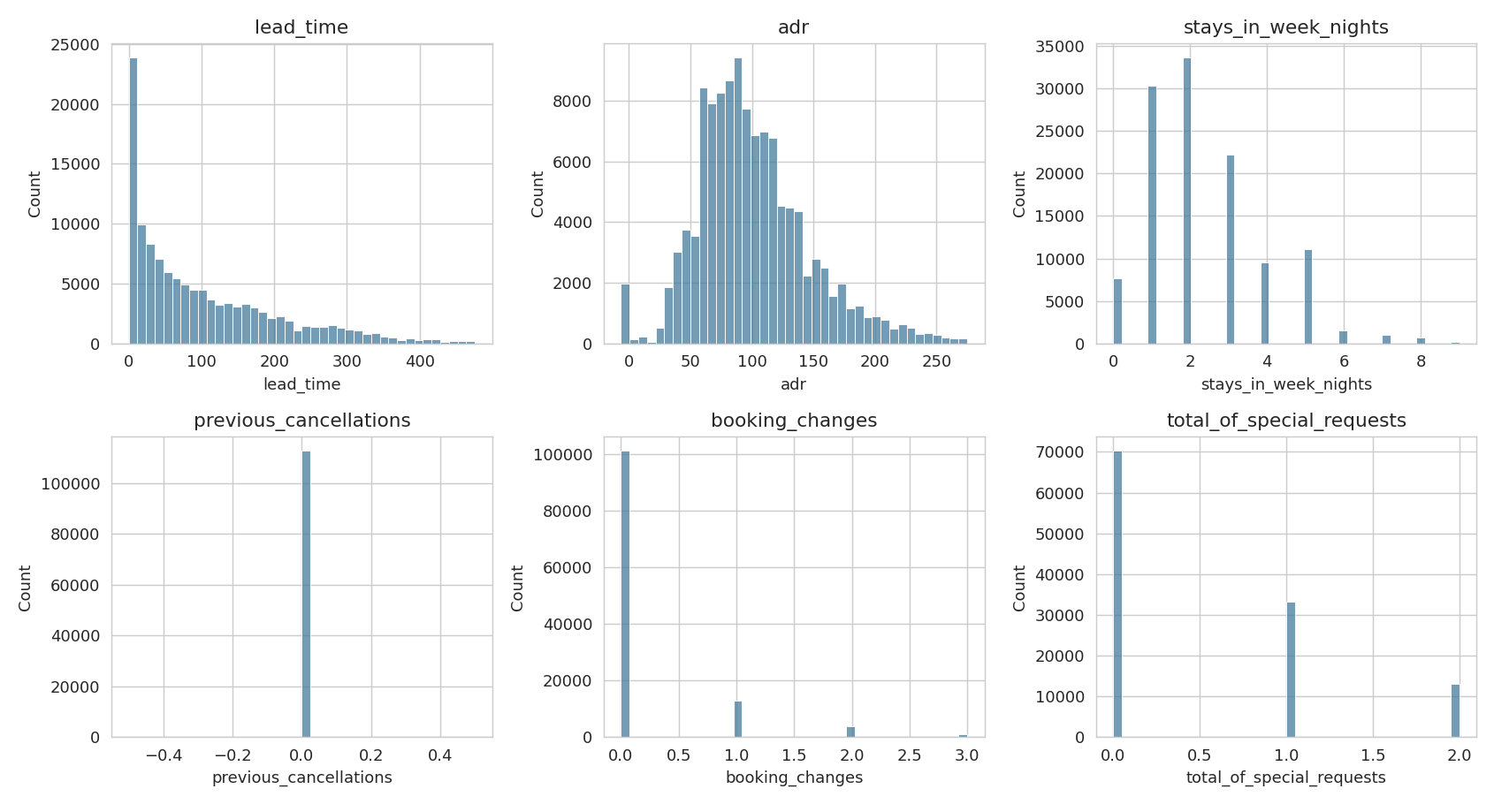
Figure 2: Distribution of key scale variables (top 0.5% trimmed for readability)
Figure 2 confirms the strong right skew in lead time, ADR, stay length and the zero-inflated shape of previous cancellations, booking changes and special requests. These shapes justify tree-based models and scaling for the linear model.
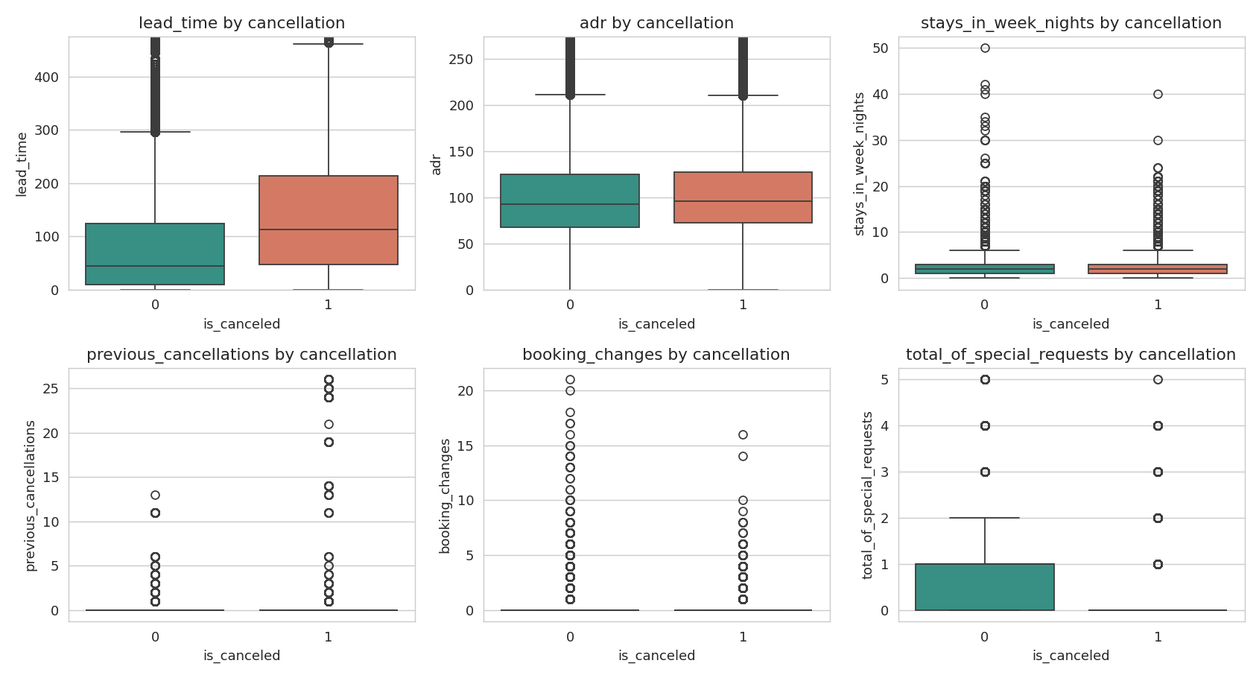
Figure 3: Key scale variables by cancellation status
Cancelled bookings were made much earlier (higher lead_time), had more prior cancellations, and had fewer special requests and booking changes. ADR and weeknight stays look nearly identical across the two groups.

Outliers (IQR rule)
Variable | Outliers | % of rows
lead_time | 3,005 | 2.52
stays_in_weekend_nights | 265 | 0.22
stays_in_week_nights | 3,354 | 2.81
adults | 29,710 | 24.88
children | 8,590 | 7.19
babies | 917 | 0.77
is_repeated_guest | 3,810 | 3.19
previous_cancellations | 6,484 | 5.43
previous_bookings_not_canceled | 3,620 | 3.03
booking_changes | 18,076 | 15.14
days_in_waiting_list | 3,698 | 3.1
adr | 3,793 | 3.18
required_car_parking_spaces | 7,416 | 6.21
total_of_special_requests | 2,877 | 2.41
Table 3: IQR outlier counts. Most flagged values are genuine rare behaviour (not errors) and were retained, since tree models are robust to them.
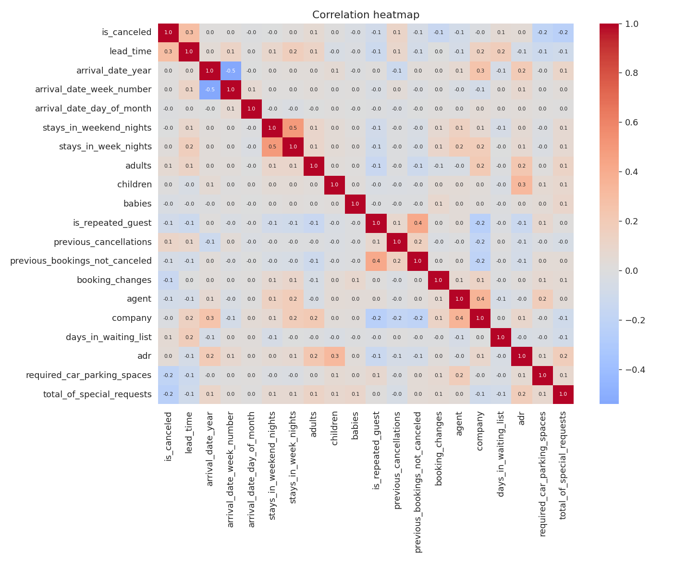
Figure 4: Correlation heatmap of numeric variables
The correlation heatmap shows no pair of predictors with problematic collinearity. The strongest relationship with the target is lead_time (+0.29); the strongest negative ones are special requests (-0.24), parking (-0.20) and booking changes (-0.14). The generally low linear correlations suggest that cancellation depends on combinations and non-linear effects, which motivates the tree-based models.

4. Frequency Distribution of Categorical Variables

4.1 Hotel type
Category | Count | % | Cancel rate %
City Hotel | 79,330 | 66.45 | 41.7
Resort Hotel | 40,060 | 33.55 | 27.8
Table 4: Frequency distribution of hotel
Two-thirds of bookings are for the City Hotel. City cancels at 41.7% versus 27.8% for the Resort, so the property type shapes risk.

4.2 Market segment
Category | Count | % | Cancel rate %
Online TA | 56,477 | 47.3 | 36.7
Offline TA/TO | 24,219 | 20.29 | 34.3
Groups | 19,811 | 16.59 | 61.1
Direct | 12,606 | 10.56 | 15.3
Corporate | 5,295 | 4.44 | 18.7
Complementary | 743 | 0.62 | 13.1
Aviation | 237 | 0.2 | 21.9
Undefined | 2 | 0.0 | 100.0
Table 5: Frequency distribution of market_segment
Online travel agents (47.3%) and offline TA/TO (20.3%) dominate. Groups cancel at 61.1% - by far the highest among sizeable segments - while Direct (15.3%) and Corporate (18.7%) are the most reliable.

4.3 Deposit type
Category | Count | % | Cancel rate %
No Deposit | 104,641 | 87.65 | 28.4
Non Refund | 14,587 | 12.22 | 99.4
Refundable | 162 | 0.14 | 22.2
Table 6: Frequency distribution of deposit_type
87.7% of bookings carry no deposit (28.4% cancelled). Surprisingly, 99.4% of the 14,587 "Non Refund" bookings were cancelled. This counter-intuitive pattern (a non-refundable deposit should deter cancellation) is a known feature of this dataset, probably linked to specific group/agent practices or to how these bookings were recorded; the model uses it as the single strongest signal, but a manager should treat it with caution rather than as a causal law.
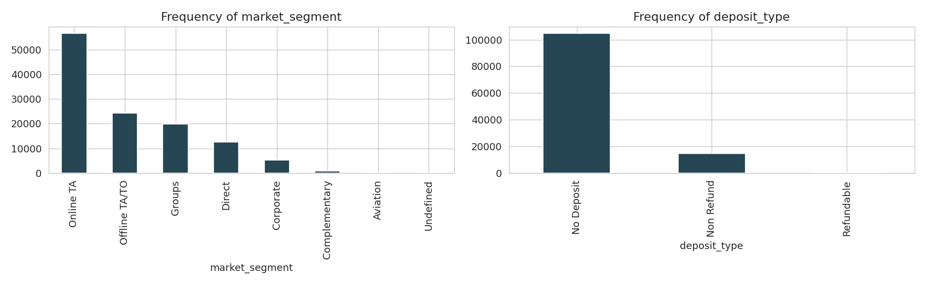
Figure 5: Frequency of market segment and deposit type

4.4 Customer type
Category | Count | % | Cancel rate %
Transient | 89,613 | 75.06 | 40.7
Transient-Party | 25,124 | 21.04 | 25.4
Contract | 4,076 | 3.41 | 31.0
Group | 577 | 0.48 | 10.2
Table 7: Frequency distribution of customer_type
Transient guests are 75.1% of bookings and cancel at 40.7%; Transient-Party 25.4%; Contract 31.0%; Group only 10.2% (a small segment of 577 bookings).
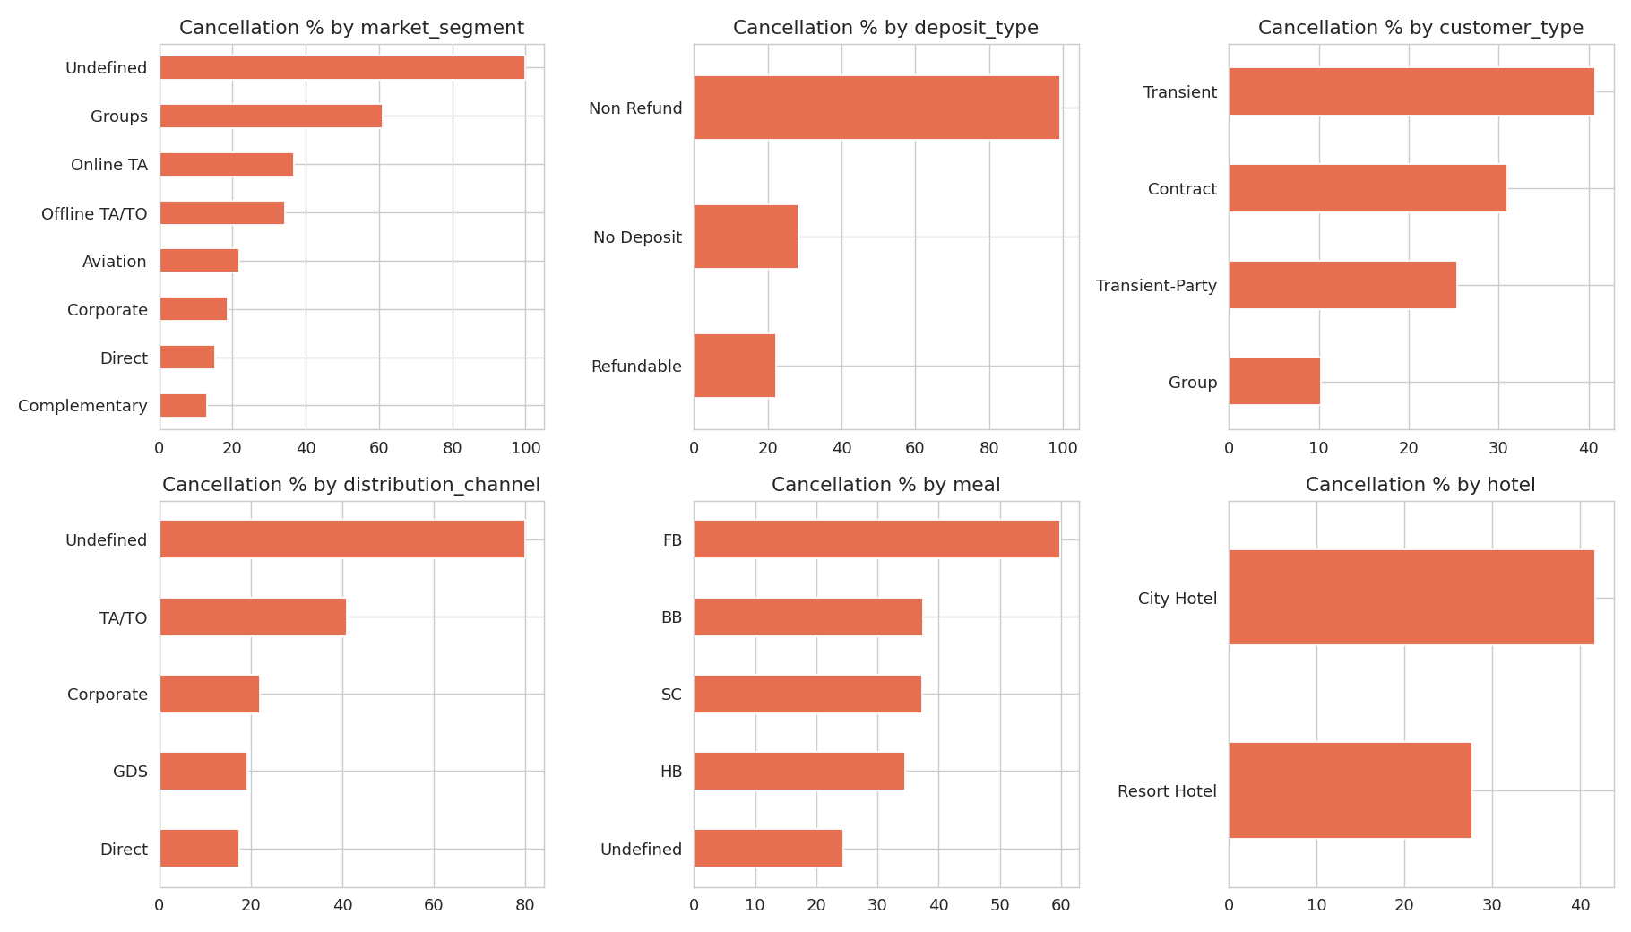
Figure 6: Cancellation rate (%) by categorical variables

4.5 Distribution channel
Category | Count | % | Cancel rate %
TA/TO | 97,870 | 81.98 | 41.0
Direct | 14,645 | 12.27 | 17.5
Corporate | 6,677 | 5.59 | 22.1
GDS | 193 | 0.16 | 19.2
Undefined | 5 | 0.0 | 80.0
Table 8: Frequency distribution of distribution_channel
Travel agents / tour operators supply 82.0% of bookings and cancel at 41.0%, versus 17.5% for Direct and 22.1% for Corporate. Booking direct is associated with commitment.

4.6 Meal plan
Category | Count | % | Cancel rate %
BB | 92,310 | 77.32 | 37.4
HB | 14,463 | 12.11 | 34.5
SC | 10,650 | 8.92 | 37.2
Undefined | 1,169 | 0.98 | 24.5
FB | 798 | 0.67 | 59.9
Table 9: Frequency distribution of meal
Bed and breakfast (BB) covers 77.3%. Cancellation rates are similar across BB, HB and SC (about 35-37%); Full Board (FB) is rare (0.7%) but cancels at 59.9%.

4.7 Reserved room type
Category | Count | % | Cancel rate %
A | 85,994 | 72.03 | 39.1
D | 19,201 | 16.08 | 31.8
E | 6,535 | 5.47 | 29.3
F | 2,897 | 2.43 | 30.4
G | 2,094 | 1.75 | 36.4
B | 1,118 | 0.94 | 32.9
C | 932 | 0.78 | 33.0
H | 601 | 0.5 | 40.8
P | 12 | 0.01 | 100.0
L | 6 | 0.01 | 33.3
Table 10: Frequency distribution of reserved_room_type
Room A is 72.0% of bookings (39.1% cancelled). Other types are smaller with broadly similar rates; types P and L have fewer than 15 bookings, so their rates are unreliable.

4.8 Country (top 10)
Country | Count | % | Cancel rate %
PRT | 48590 | 40.7 | 56.6
GBR | 12129 | 10.16 | 20.2
FRA | 10415 | 8.72 | 18.6
ESP | 8568 | 7.18 | 25.4
DEU | 7287 | 6.1 | 16.7
ITA | 3766 | 3.15 | 35.4
IRL | 3375 | 2.83 | 24.7
BEL | 2342 | 1.96 | 20.2
BRA | 2224 | 1.86 | 37.3
NLD | 2104 | 1.76 | 18.4
Table 11: Frequency distribution of country
Portugal alone accounts for 40.7% of bookings, followed by Great Britain (10.2%) and France (8.7%). Portuguese guests cancel at 56.6%, versus 17-25% for Britain, France, Germany and Spain. Country of origin is therefore a major predictor.

4.9 Arrival month
Category | Count | % | Cancel rate %
August | 13,877 | 11.62 | 37.8
July | 12,661 | 10.6 | 37.5
May | 11,791 | 9.88 | 39.7
October | 11,160 | 9.35 | 38.0
April | 11,089 | 9.29 | 40.8
June | 10,939 | 9.16 | 41.5
September | 10,508 | 8.8 | 39.2
March | 9,794 | 8.2 | 32.2
February | 8,068 | 6.76 | 33.4
November | 6,794 | 5.69 | 31.2
Table 12: Frequency distribution of arrival_date_month
Demand peaks in August (11.6%) and July (10.6%) and is lowest in January (5.0%). Cancellation is highest in April-June (about 40-42%) and lowest in January and November (about 31%).
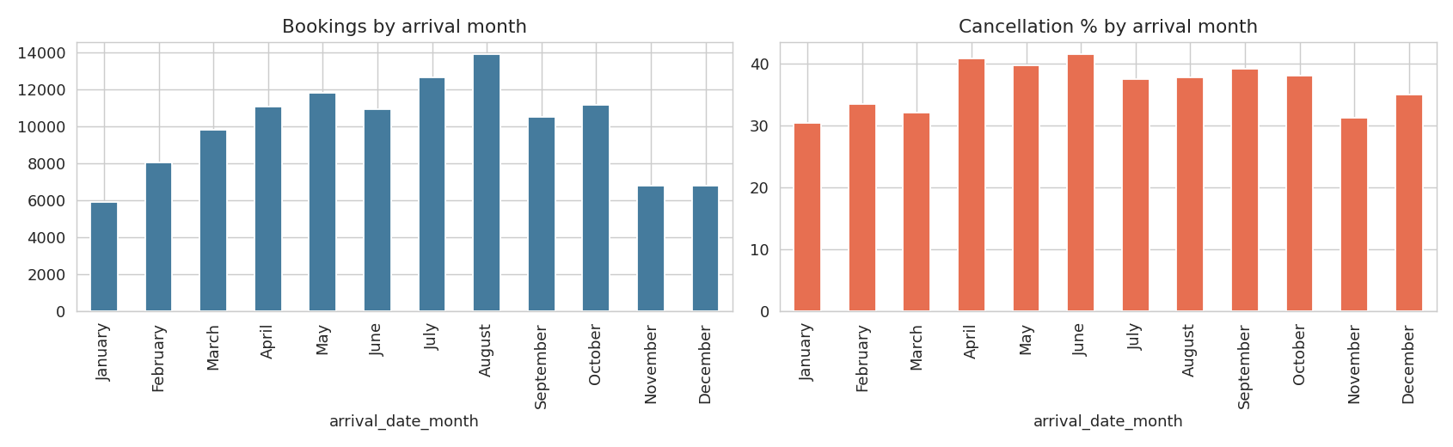
Figure 7: Bookings and cancellation rate by arrival month

4.10 Reservation status (post-outcome field)
Check-Out 63.0%, Canceled 36.0%, No-Show 1.0%. Both Canceled and No-Show are classed as is_canceled = 1, so this field is a perfect restatement of the target. It is therefore excluded from modelling to avoid data leakage.

5. Data Authenticity and Problem Identification

5.1 Source and authenticity
The data is a secondary dataset published by Antonio, Almeida and Nunes (2019), "Hotel booking demand datasets", Data in Brief, 22, 41-49 (DOI: 10.1016/j.dib.2018.11.126), and is widely hosted on Kaggle ("Hotel booking demand"). It contains real property-management-system records for two hotels in Portugal (a resort hotel in the Algarve and a city hotel in Lisbon) for arrivals between 1 July 2015 and 31 August 2017. The authors anonymised the data: no guest names, contact or payment details are included, and hotel identities are not disclosed. It is therefore suitable for academic use, and we used it only for aggregate statistical modelling with no attempt to identify individuals.

5.2 Data-quality findings
- Missing values: company 94.3% (112,593 rows), agent 13.7% (16,340), country 0.4% (488), children 4 rows. company and agent are blank because many bookings have no company or agent, so the missingness is meaningful; both were excluded as identifiers. Missing children were set to 0 and missing country to "Unknown".
- Duplicates: 31,994 rows (26.8%) are exact duplicates on every column. Because the data has no booking ID, some are genuine separate bookings with identical attributes (e.g. several rooms in one group reservation), so they were retained, but this is a limitation noted below.
- Implausible values: negative ADR (-6.38), ADR of 5,400, bookings with zero guests, and up to 55 adults. These are few and were kept for the tree models; they would be investigated with the hotel in practice.
- Leakage: reservation_status and reservation_status_date reveal the outcome and were removed. assigned_room_type is assigned near check-in and can partly depend on whether the guest arrived; we retained it for comparability with the supplied notebook but flag it as a potential leakage risk.

5.3 Limitations of the data
- Only two hotels, both in Portugal, and 2015-2017: results may not generalise to other markets or to post-pandemic behaviour.
- Currency, hotel names and price context are undisclosed; the strong Portugal and Non-Refund effects may reflect local booking practices.
- No booking ID, so duplicate records cannot be definitively resolved; no information on cancellation date relative to arrival.

5.4 ML problem definition
The task is binary classification: given information available when a booking is made, predict is_canceled. Success is measured primarily by recall and F1 for the cancelled class (missing a cancellation is costly) plus ROC-AUC for ranking quality. The problem is well suited to ML because the target is labelled, the sample is large (119,390), the relationships are non-linear and combinatorial, and the output (a risk score per booking) is directly actionable for overbooking and deposit decisions.

6. Analysis

6.1 Methodology
- Feature engineering: arrival month converted to a number; country reduced to the 10 most frequent plus "Other"; categorical variables one-hot encoded (drop-first), giving 69 predictors.
- Train-test split: 70% / 30% stratified (83,573 train / 35,817 test), random_state = 42.
- Scaling: StandardScaler fitted on the training set only, then applied to the test set.
- Class imbalance: SMOTE applied to the training set only, balancing it to 52,616 vs 52,616. The test set keeps its natural 63/37 split so scores reflect real conditions. (Applying SMOTE before the split, as in the draft notebook, lets synthetic copies of test-set neighbours leak into training and inflates every score, so the pipeline was corrected.)
- Models: Logistic Regression (interpretable baseline), Decision Tree with max depth 5 (transparent rules), and Random Forest (non-linear ensemble). The Random Forest was then tuned with RandomizedSearchCV (ROC-AUC, 2-fold CV on a 20,000-row subsample for speed); the best settings (100 trees, no depth limit, min_samples_leaf = 1) were refit on the full balanced training set.

6.2 Model comparison
Model | Accuracy | Precision | Recall | F1 | ROC-AUC
Logistic Regression | 0.810 | 0.727 | 0.781 | 0.753 | 0.894
Decision Tree (depth 5) | 0.809 | 0.738 | 0.753 | 0.745 | 0.871
Random Forest | 0.850 | 0.804 | 0.786 | 0.795 | 0.928
Tuned Random Forest | 0.887 | 0.865 | 0.823 | 0.843 | 0.953
Table 14: Test-set performance (positive class = Canceled)
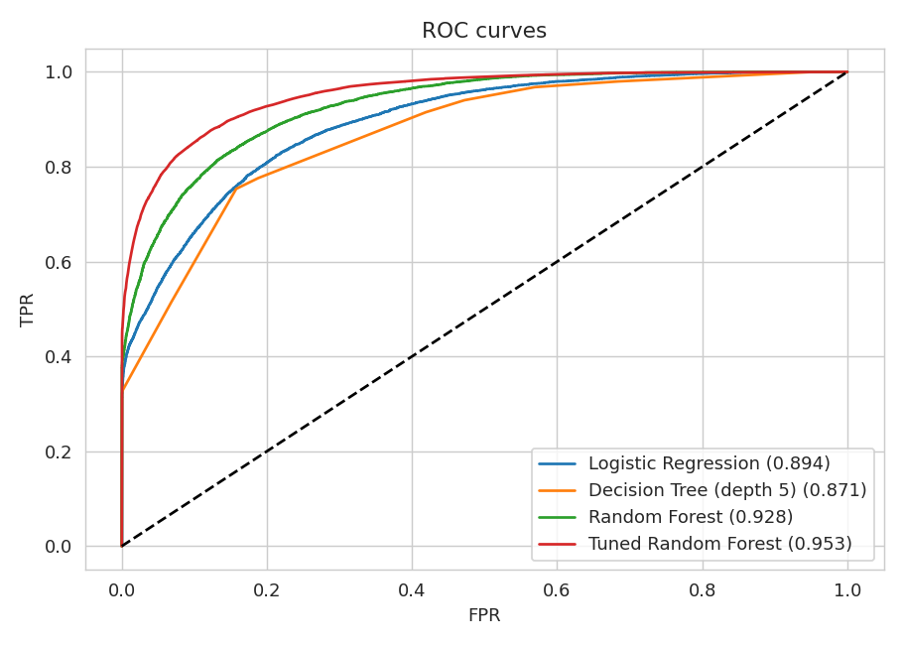
Figure 8: ROC curves of all models
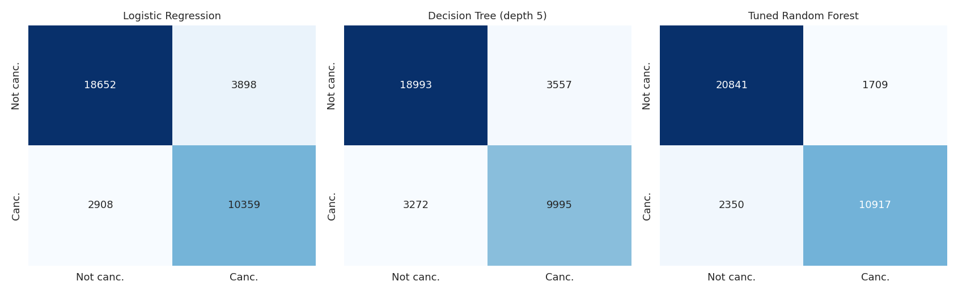
Figure 9: Confusion matrices
Reading the table: the Logistic Regression and Decision Tree reach about 81% accuracy and F1 near 0.75. The untuned Random Forest improves to 85.0% accuracy and F1 0.795. The tuned Random Forest is best on every measure: accuracy 88.7%, precision 0.865, recall 0.823, F1 0.843 and ROC-AUC 0.953. For the tuned forest, 10,917 of 13,267 cancellations in the test set were correctly caught (recall 82.3%), at the cost of 1,709 false alarms among 22,550 honoured bookings. Precision of 86.5% means that about 7 in 8 bookings flagged as high-risk really do cancel.

6.3 Feature interpretation
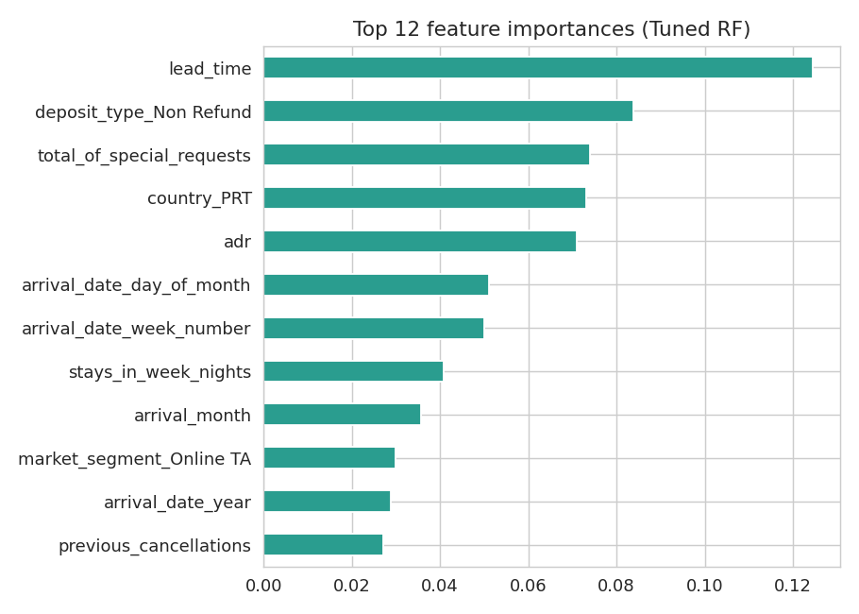
Figure 10: Top 12 feature importances (tuned Random Forest)
The most important predictors are lead time, Non-Refund deposit, number of special requests, Portuguese origin, and ADR, followed by arrival week/day/month and previous cancellations. The Logistic Regression coefficients agree in direction: previous cancellations (+1.97), Non-Refund deposit (+1.57), Portuguese origin (+1.14), Online TA segment (+0.86) and lead time (+0.50) raise cancellation odds, while required parking spaces (-2.21), special requests (-0.65) and previous completed stays (-0.61) lower them. Importances show which variables the model uses, not that they cause cancellations.

6.4 Transparent and ethical use of AI tools
An AI assistant (Claude) was used to run the analysis pipeline, generate charts and draft this report from the group's notebook and dataset. The group reviewed and is responsible for the results, can explain each step, and the AI tool was used in line with the institute's plagiarism and AI guidelines. All code and data are shared in the GitHub submission so that results can be reproduced. A Turnitin report is submitted separately.

7. Outcome of the Study

7.1 Conclusions
- Cancellation is predictable at booking time: the tuned Random Forest identifies 82% of cancellations with 86% precision and an AUC of 0.95, clearly outperforming the linear (AUC 0.89) and shallow-tree (0.87) baselines. Non-linear interactions matter.
- Risk is concentrated. The highest-risk bookings are long-lead-time, no-special-request, Portuguese-origin bookings from group or online-agent channels, and those with a history of cancellations. The lowest-risk are direct, corporate, repeat and parking-booking guests.
- The City Hotel cancels more than the Resort (41.7% vs 27.8%) and spring (April-June) is the peak cancellation season.

7.2 Actionable recommendations
- Use the model score for selective, risk-based overbooking rather than a flat percentage: overbook more on high-score bookings only.
- Offer incentives to convert agent bookings to direct bookings, and send reminders or request deposits for long-lead bookings.
- Encourage guests to add special requests and parking (small personalisation steps that are associated with commitment).
- Investigate the Non-Refund bookings: a 99.4% cancellation rate suggests a data or process issue worth checking with the hotel, since the policy is not deterring cancellations.

7.3 Limitations and future work
Results are specific to two Portuguese hotels over 2015-2017 and were validated on a single random split, so performance on future periods may be lower; a time-based split would be a stricter test. The duplicate rows, the Non-Refund anomaly and possible leakage via assigned_room_type could flatter accuracy. The recall of 82% means roughly one cancellation in six is still missed, and false positives could lead a hotel to over-restrict genuine guests, so the model should support rather than replace manager decisions. Future work: time-based validation, gradient boosting (XGBoost / LightGBM), probability calibration, threshold tuning against actual cost of an empty room versus a walked guest, and removal of assigned_room_type.

8. Conceptual Understanding of the Problem and Algorithms
- Exploratory data analysis: Descriptive statistics summarise centre and spread; skewness and the mean-median gap reveal long-tailed variables; frequency tables and cancellation rates per category reveal where risk concentrates; correlations show linear association only.
- SMOTE: creates synthetic minority-class examples by interpolating between a cancelled booking and its nearest cancelled neighbours. It must be applied only to training data, otherwise evaluation becomes optimistic.
- Logistic Regression: models the log-odds of cancellation as a linear combination of features. Its coefficients are interpretable (sign and size of effect) but it cannot capture interactions on its own.
- Decision Tree: repeatedly splits the data on the feature and threshold that best separates cancelled from non-cancelled bookings (Gini impurity), producing readable rules; a shallow depth limits overfitting but also accuracy.
- Random Forest: averages many trees trained on bootstrap samples with random feature subsets (bagging), reducing the variance of a single tree and capturing non-linear interactions; feature importance comes from the total impurity reduction.
- Evaluation metrics: accuracy is misleading when classes are imbalanced; precision (how many flagged bookings really cancel), recall (how many cancellations are caught), F1 (their balance) and ROC-AUC (ranking quality across all thresholds) are used together. The right balance between precision and recall depends on the business cost of each error type.
- Hyperparameter tuning: RandomizedSearchCV samples settings (trees, depth, leaf size) and scores each with cross-validation, a cheaper alternative to exhaustive grid search.

References and Submission Items
- Antonio, N., Almeida, A., & Nunes, L. (2019). Hotel booking demand datasets. Data in Brief, 22, 41-49. https://doi.org/10.1016/j.dib.2018.11.126
- Dataset (secondary): "Hotel booking demand", Kaggle (hotel_bookings.csv).
- Chawla, N. V., et al. (2002). SMOTE: Synthetic Minority Over-sampling Technique. Journal of Artificial Intelligence Research, 16, 321-357.
- Breiman, L. (2001). Random forests. Machine Learning, 45, 5-32.
- Pedregosa, F., et al. (2011). Scikit-learn: Machine learning in Python. JMLR, 12, 2825-2830.
Items to attach by the group: Turnitin report (library), dataset and code on GitHub (repository link to be added: [GitHub link]), submitted before the deadline by each member.

